**Cleaning and sanitisation basics for workplaces**

May 13, 2020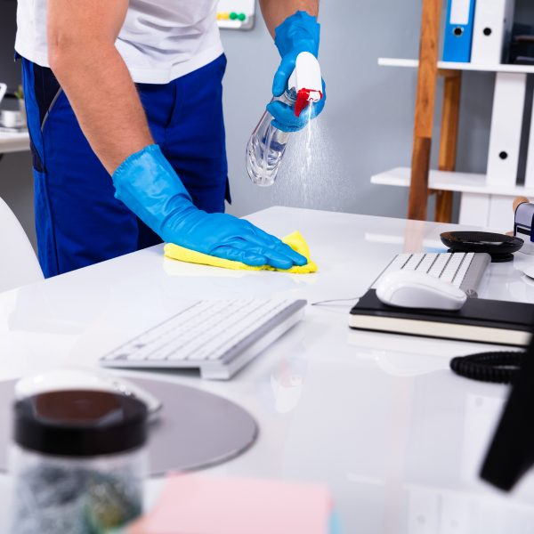

Many businesses are currently in the process of refining or developing their business continuity plan around sanitisation and infection control measures and how to continue or restart operations while being impacted by a worldwide health crisis.  Management teams are implementing strategies to manage everything from communication with employees and managing remote operations, through to the implementation of disinfection procedures.

A health crisis places businesses under increased pressure, and often for a considerable length of time.  Now is the time to take action in relation to COVID-19 and implement a business continuity plan to address risk factors that are critical to your business.

Simple precautions and planning can make a big difference.

As has been well-documented already, the best way to prevent and slow down transmission is by washing your hands with soap and water and frequent use of an alcohol-based rub, along with isolation and risk elimination methods. Sanitisation is only one part of the story.

**Why is it important to sanitise surfaces?**

COVID-19 is a respiratory illness that spreads easily from person to person via infected droplets from exhaling, sneezing or coughing. People may contract the virus by touching an infected surface or object, and then touching their nose, mouth or eyes.

At its most basic, the virus can be transferred from an infected person to surfaces via aerosols/droplets or contact. Other people who come into contact with the infectious material can then be infected.

It is important to sanitise surfaces because:

* It reduces the infectious load on surfaces and reduces the risk of transmission of the virus to other people
* If you have a case, sanitisation can provide confidence of which other workers may have been impacted from surface transmission. This supports traceability and the necessary actions that need to be taken afterwards in response

**What does this look like in the workplace?**

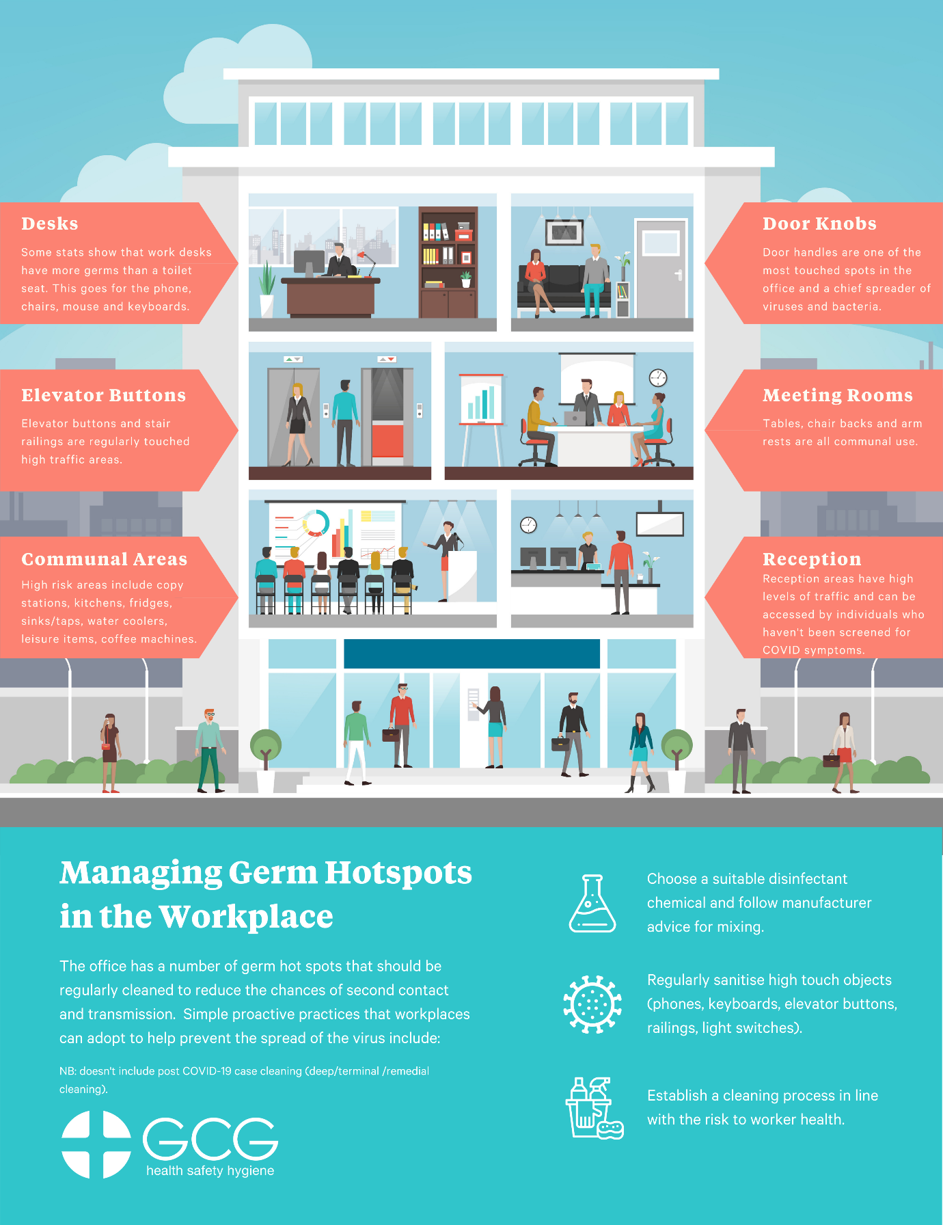

**How can you make decisions for your workplace on cleaning types and frequency?**

Methods exist which can support risk-based decision making on how and when to clean your workplace. There are specific examples from reputable guidance on how and when to clean workplaces, however, it doesn’t translate well to wider workforces, as it is focussed on public spaces, schools, homes. This information isn’t particularly useful to those that don’t fall into those sectors or areas.

As this isn’t practical or applicable for all workplaces, GCG has been working with clients to develop custom fact-based decision-making tools which account for individual factors in the workplace. This incorporates grading surfaces by touch frequency amongst other critical items of information.

**The role of sanitisation in preventing transmission**

While every employer’s business continuity plan should be tailored to its circumstances, some sites may require thorough sanitisation or decontamination of high risk/traffic areas as a precaution or if the area has been potentially exposed to the virus. Proactive decontamination and clearances are suggested for critical assets to keep operational and mobilised. This reduces risk by disinfecting and validating the cleanliness of high touch surfaces to reduce the chances of second contact and transmission.

This control forms part of an overall risk reduction strategy and could be considered for critical operational locations such as:

* Operational vehicles such as trucks, cranes, light vehicles etc
* Critical office infrastructure
* Public transport such as buses, trains
* Control rooms
* Workforce lunchrooms/crib rooms
* Call centres

To safely sanitise and disinfect a location with known or suspected COVID-19 exposure, GCG recommends utilising an independent cleaning provider that follows decontamination methods outlined by State and Federal Government bodies, including the [Department of Health](https://www.health.gov.au/sites/default/files/documents/2020/03/environmental-cleaning-and-disinfection-principles-for-covid-19.pdf). Cleaning should be conducted regularly to reduce the risk of infection.  The Department of Health recommends that all hard surfaces, furniture, equipment and frequently touched surfaces (including door handles, elevator buttons, light switches) be thoroughly cleaned using detergent and bleach. Any fabric or upholstered furniture should be steam cleaned.

Some industries and workplaces may face a high risk of infection due to the nature of their businesses and worksites. For example, local councils are required to maintain public transport services where possible to support the community. However, public transport is particularly vulnerable to disease outbreaks due to the high volume of passengers in a confined space with limited ventilation. Implementing proactive infection prevention methods helps to contain the disease while keeping cities mobilised.

By conducting regular sanitisation assessments of the worksite and evaluating the effectiveness of the cleaning methods employed, businesses can respond to any risks present and in turn, keep their people safe.

**Sanitisation Assessment and Validation**

Following the proactive or reactive decontamination and disinfection, GCG will conduct a thorough clearance inspection and [sanitisation assessment](https://www.gcg.net.au/service/covid-19-sanitisation-assessment/) to determine the effectiveness of the hygiene intervention. GCG uses specialised scientific testing equipment and a range of qualitative assessment methods to review the site.

Depending on the results, GCG will provide clearance for the site or make recommendations around additional decontamination actions.

**We are here to help you get through this safely.**

We know that businesses around Australia are facing an unprecedented challenge.  GCG recognises the difficulty of adapting a business to continue operations while protecting the health and safety of its employees. Our consultants take pride in producing quality yet effective work to ensure clients hold a clear advantage – to continue operations as per usual and to keep the issue contained and/or eliminated.

The main part of our job is to figure out the clients’ requirements based on size, scope, location, and budget to fully understand what is expected. GCG clients are not alone during this time of uncertainty and challenge, we are here to help you get through this safely.